The George Washington University
School of Engineering and Applied Science
Department of Computer Science

Final Project Report

for

Voice Launch

By

Amir Raminfar

CSci 196-11
Senior Computer Science Design Project

Abstract of Final Project Report for
Voice Launch
by
Amir Raminfar

Voice Launch is a speech recognition program that will recognize and launch a selection of at least fifteen phrases. Each phrase is associated with one application. The user will need to record a number of phrases and associate each phrase with an application. The expected accuracy is equal or greater than 80%. To launch an application via voice, the user’s phrase is recorded and passed to the recognition thread. The recognition thread will find the most similar item from the library by comparing the recorded phrase to all other templates in the library. A template holds features of a previously recorded phrase and is stored in the library. The user is prompted with a confirmation dialog prior to launching any application. If the found application is not what the user desired, then he or she can click or say no and the next best application is chosen. If, after three attempts, the correct application was not found, then no application is launched.

The project consists of nine main modules. The modules include Record, Save to Disk, Insert to Library, Sample, Recognize, Continuous Recording and Launch Application. Furthermore, the project consists of a Library and Graphical User Interference. The program will require a machine of at least 800 MHz and at least 256 MB of RAM. A microphone is required for recording speech and speakers are recommended for playback.

The project required 36 weeks to complete and needed an estimated 462 hours of labor at a cost of $17,640. A working prototype was completed with a cost of $59,270.

Dedicated to my mother, father and sister for believing
in me and helping make my dreams come true.
I appreciate all the hard work you have done for me.

TABLE OF CONTENTS

Abstract............................................................................................................................................ii
List of Figures.................................................................................................................................iv
List of Tables...................................................................................................................................v
1. Introduction 7
2. Specifications of the Project 8
3. Theory 9
4. Design of the Project 11
4.1 Record Module 13
4.2 Save to Disk Module 13
4.3 Insert to Library Module 14
4.4 Sample Module 15
4.5 Recognize Module 15
4.6 Launch Application Module 16
4.7 Feature Extractor Module 17
4.8 Continuous Recording Module 17
4.9 Library 18
4.10 Graphical User Interface 18
5. Module List 20
6. History 21
7. Tests to Verify the Design 22
8. Labor Costs by Week 25
9. Economic Analysis 27
10. Conclusion 29
11. References 30
Appendix A – Definitions
Appendix B – User Manual
Appendix C – Project Source Code
Appendix D – JavaDoc for Source Code

LIST OF FIGURES

Figure 1 - DTW Algorithm 9
Figure 2 - Example Matrix for DTW 10
Figure 3 - Neighboring Elements for DTW 10
Figure 4 - Resulting Matrix for DTW 10
Figure 5 – Block Diagram of Modules 12
Figure 6 - PDL for Record and Filter 13
Figure 7 - PDL for Saving to Disk 14
Figure 8 - PDL for Inserting to Library 14
Figure 9 - PDL for Sampling 15
Figure 10 - PDL for Recognition 16
Figure 11 - PDL for Launching Application 16
Figure 12 - PDL for Feature Extractor Module 17
Figure 13 - PDL for Continuous Recording 17
Figure 14 - PDL of Library 18
Figure 15 - PDL for Graphical User Interface 19
Figure 16 – Cumulative Labor Cost Graph 26

LIST OF TABLES

Table 1 - Module List 20
Table 2 - Verifications 22
Table 3 - Labor Costs by Week 25
Table 4 - Prototype Cost 27
Table 5 - Unit Costs 28

Introduction

This is the final report for Voice Launch. Voice Launch is a speech recognition program which allows users to launch applications via voice. It allows the user to record a number of phrases and associate each phrase with an application. When the user repeats that phrase, it attempts to find that phrase and launch the application which it is associated with. This report consists of 12 chapters and four appendices.
Chapter 2 presents the system requirements needed to run Voice Launch. Chapter 3 discusses the theory behind speech recognition, and chapter 4 presents the design of the project.
Chapter 5 displays all modules for Voice Launch. Chapter 6 contains the history and changes which took effect during the design and implementation of this project. Chapter 6 includes all the tests that were performed to ensure the correctness of the project. Chapter 8 and 9 discuss the economical analysis of this project. Chapter 8 shows a detailed view of cost by week while chapter 9, shows the computation for the cost of prototype and the estimated profit.
Appendix A provides a definition for all terms used in this report. Appendix B is the user manual for Voice Launch. Appendix C includes the source code for the project, and finally appendix D contains the JavaDoc for the source code.

Specifications of the Project

Voice Launch uses theory of speech recognition to differentiate between vocabularies of up to fifteen words. The user can then relate each word to an application that he or she would like to launch. As a result, the project must keep a collection of WAV file features, or also called templates, which were previously recorded by the user. To launch an application, the user will trigger an event which will display a dialog and immediately start recording for the duration of two seconds. Once the user’s phrase is captured and converted into digital signal, it can then be recognized and the correlating application is launched. This project will assume 80% accuracy.
The minimum system requirements are:
  - Microphone
  - Speakers (Not required but recommended)
  - Windows XP (C and C++ are operating system dependent languages)
  - At least 800 MHz Processor
  - At least 256 MB RAM
  - Keyboard
  - Java Virtual Machine
  - Enough disk space to save the WAV files (Less than one megabyte per wav file)
  - Estimated less than 1000 ms for computation time

The use of Java will minimize the steps for recording and playing WAV files. However, Java also does not allow any system calls to the operating system, thus making it impossible to implement global hotkeys or system tray icons. The implementation of hotkeys will be done in C++ and embedded in Java. This information is all also presented in the User Manual. User Manual is presented in Appendix A.

Theory

Dynamic Time Warping (DTW) is a pattern recognition algorithm that has been used commonly for speech recognition projects with a small sized vocabulary. DTW requires two arrays of features of equal size. For this project, the features that are extracted from each sample are the zero-crossings. A zero-crossing occurs when a waveform changes sign by crossing the zero-amplitude axis. For example, going from 1 to -1 qualifies as one zero-crossing and then going back from -1 to 1 (or any other positive number) is another zero-crossing. To compute zero-crossings for each sample, the sample’s data is divided into 100 intervals and then for each interval the number of zero-crossings is computed. The process of calculating the number of zero-crossing is later discussed in more detail.
Once all the features are extracted, DTW algorithm is used for pattern recognition. This algorithm was used for its ease of implementation and high accuracy rate for a small number of vocabularies. The algorithm for DTW is shown on Figure 1:

- M(i,j) = |sample_feature(i) – template_feature(j)|
- FOR i=1 to i<size(M)
- M(i,0) += M(i-1,0)
- M(0,i) += M(0,i-1)
- End FOR
- FOR i = 1 to i < size(M)
- FOR j = i to j < size(M)
- min = MIN (M[i][j - 1], M[i - 1][j], M[i - 1][j - 1]));
- M(i,j) += min;
- End FOR
- IF i + 1 < size(M)
- FOR j = i + 1 to j < size(M)
- min = MIN (M[j][i - 1], M[j - 1][i], M[j - 1][i - 1]);
- M(j,i) += min;
- End FOR
- End IF
- End FOR
Figure 1 - DTW Algorithm

An example is presented to help understand the concept of DTW. Assume that S₁ and S₂ are given features for two samples. S₁ and S₂ have the following features: {1, 6, 9, 6, 5} and {2, 6, 8, 9, 8} respectably.
Figure 2 shows the matrix after all elements are computed. To clarify, the bottom row is computed by |2 – 1| which is 1, |2 – 6| which is 4, |2 – 9| which is 7, |2 – 6| which is 4 and |2 – 5| which is 3.

7 | 2 | 1 | 2 | 3  End of the matrix
8 | 3 | 0 | 3 | 4
7 | 2 | 1 | 2 | 3
5  Beginning of the matrix | 0 | 3 | 0 | 1
1 | 4 | 7 | 4 | 3
Figure 2 - Example Matrix for DTW

Following the algorithm, for the first row, the i^{th} element is computed by summing all elements up to the i^{th} element. So for example the first row is 1, 4, 5, 4, 3 and 1 is the first element. For the first iteration, 1 will remain to be 1. The second iteration 4 will become 5, 7 will become 13 and 4 will become 16. Finally, the last element in this row sums all the elements and replaces 3 with that value. As a result, 3 will be replaced by 19. This algorithm is again repeated for the first column starting at 1.
After the first column and row are computed, the algorithm steps through the matrix and adds to itself the neighbor with the minimum value. Figure 3 displays all possible neighbors for the i^{th} row and j^{th} column element.
i,j
i-1,j
i-1,j-1
i,j-1
Figure 3 - Neighboring Elements for DTW

Figure 4 shows the final matrix after all elements have been computed. The value at the top-right corner is the value which represents the length of the shortest distance from the beginning of the matrix to the end of the matrix. A smaller value means a closer match between the sample and template. Therefore, the template with the smallest value is chosen to be the closest match to the sample.
Final Distance Value
28 | 8 | 3 | 4 | 7
21 | 6 | 2 | 5 | 8
13 | 3 | 2 | 4 | 7
6 | 1 | 4 | 4 | 5
1 | 5 | 12 | 16 | 19

Figure 4 - Resulting Matrix for DTW

Design of the Project

This project consists of nine modules. There are four modules which together record the user’s voice, extract its features and finally insert them into the library. There are another three modules needed to sample, recognize and launch the application which is mapped to the recognized phrase. The program will also have Graphical User Interface (GUI) and Library modules. It is required for the user to build a collection of WAV files that can be placed into the library. The items in the library are called templates. Each template holds features extracted from the WAV file and the application which will be launched for that WAV file. The audio is recorded in mono with a sample rate of 16,000 samples per second. The length of each WAV file is two-seconds. The extracted features are the number of zero-crossings for each interval. There will be further detail provided on the Feature Extraction module.
As illustrated in Figure 5 and as previously stated, the Record module records the WAV file. Once the user is satisfied with the resulting WAV file, it will be written to disk in the Save to Disk module. The newly recorded WAV file is placed in into a collection of WAV files and its features are extracted in the Feature Extractor module. This module finds the number of zero-crossing for each interval. A zero-crossing occurs when a waveform changes sign by crossing the zero-amplitude axis. The length of each WAV file is two-seconds or 2,000ms. There will be a total of 100 intervals, each having the length 20ms. However, before calculating the zero-crossings, the WAV file’s excessive background noise is first removed. The noise is removed by first scanning and finding the maximum sample located in the first 100ms interval. Anything less than the maximum value is zeroed out in the beginning and the end of the phrase. The features along with the application mappings are passed to the Insert Library module which saves all necessary information to disk. The Sampling module, similar to the Record module, is responsible for recording the user’s phrase and sending it to the Recognize module. The Recognize module, which is the most complicated module, is responsible for recognizing and finding the closest match. The Recognize module will first extract the sample’s features by passing it to the Feature Extractor. After all the features are extracted, the Recognize module will use the DTW algorithm to find the best-matched template and finally, the last module will launch the user’s application which was previously selected.
The GUI module is where all the events are triggered. Depending on the event, the GUI calls either the Record or Sample module. The GUI also has access to the library for maintenance purposes. The library keeps a record of WAV-file-to-application mappings and a folder to store the WAV files. Access to the library is needed to recognize which phrase the user spoke and to retrieve which application is mapped to that phrase.

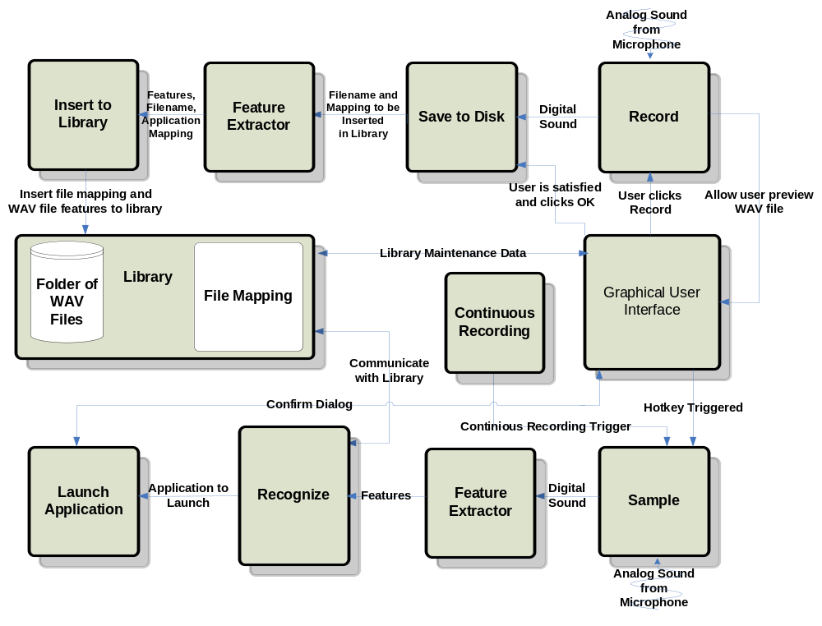
Figure 5 – Block Diagram of Modules

The user also has the ability to say “computer,” as opposed to using the mouse or keyboard to initiate the recognition phase. Figure 5 shows the Continuous Recording module and how it communicates with the Sample module. The Continuous Recording module is able to trigger events so that the recognition phase can be initiated.

Record Module

Figure 6 displays the steps needed to record with Java for two seconds. An instance of AudioInputStream is used because it expands the buffer as needed and therefore making it a lot easier for the project by not worrying about memory management. The audio is recorded at a rate of 16000 Hz. This project does not require the WAV files to be at a very high rate such as 441000 Hz. Record module does not take any parameters, however when it is done recording it returns an instance of AudioInputStream to the GUI.

Parameters: IN (Nothing)
OUT (AudioInputStream: audioInputStream)

- Initialize AudioLine
- Create AudioFormat
- If Line Does Not Supports format then return with error
- Open line
- Start recording on line
- While (Time in Microseconds /1000/1000) < 2
- Read data from line into a temporary buffer
- Place the temporary buffer into a OutputStream
- End while
- Stop and close line
- Flush and close
- Convert ByteArrayOutputStream to ByteArrayInputStream
- Convert ByteArrayInputStream to AudioInputStream
- Return AudioInputStream to GUI so that user can preview

Figure 6 - PDL for Record and Filter

Save to Disk Module

Once the user is satisfied with his or her recording, it is the responsibility of the next module to save the WAV file to disk. Save To Disk module takes an instance of AudioInputStream as one of its parameters and the application which is launched when the recognize module distinguishes this phrase. The WAV file is saved to disk so that the user can later hear it and modify it if needed. The next module will extract features from WAV files and will only use these features to recognize. Figure 7 displays the steps needed to save a WAV file to disk.

Parameters: IN (AudioInputStream: audioInputStream,
Application Filename: filename)
OUT (WAV file, Application Filename: filename)

- Check to see audioInputStream is not null
- Reset to beginning of Stream
- Parse the name of the application
- Create a new file with the same name of application
- Write audioInputStream with filename
- If Write returns -1 then throw exception
- Insert to library with new created WAV file and application mapping

Figure 7 - PDL for Saving to Disk

Insert to Library Module

In this module, the features of the sample file are extracted and saved to the library. In addition, the library also saves which application will be launched in relationship with this sample. This information is saved into a file which resides on the disk. Figure 8 display the steps for inserting items in to the library.

Parameters: IN (Sample Features: samplefeatures,
Application Filename: filename)
OUT (Nothing)

- Open sample file
- Open database file
- Append 100 features to database file and application that it is mapped to
- Close file
- Update GUI if needed

Figure 8 - PDL for Inserting to Library

Sample Module

The Sample module is very similar to Record. As shown in Figure 9, the algorithm is identical to record and filter module. The only subtle difference is that the recorded sample must be passed to the next module so that its features become extracted.

Parameters: IN (Nothing)
OUT (AudioInputStream: audioInputStream)

- Initialize AudioLine
- Create AudioFormat
- If Line Does Not Supports format then return with error
- Open line
- Start recording on line
- While (Time in Microseconds /1000/1000) < 2
- Read data from line into a temporary buffer
- Place the temporary buffer into a OutputStream
- End while
- Stop and close line
- Flush and close
- Convert ByteArrayOutputStream to ByteArrayInputStream
- Convert ByteArrayInputStream to AudioInputStream
- Call recognize module with AudioInputStream as a parameter

Figure 9 - PDL for Sampling

Recognize Module

As shown in Figure 10, first, the samples features are extracted by using the feature extractor module. For every template, a matrix of size 100 by 100 is created. Each row of the matrix is populated by taking the difference of one feature from the sample and comparing it with all the features in the template. This method normalizes the template and sample. After completing this step with all the features in the sample, the next step is to perform a pattern matching algorithm. Dynamic Time Warping (DTW) walks through the matrix and computes the shortest distance from the top-right to the bottom-left corner. The template with the shortest path is chosen and the associated application is returned to the launch application module.

Parameters: IN (Recorded Sample: sample)
OUT (String: Best matched application)

- Extract features from sample
- Get all templates from library
- For every template
- M(i,j) = |sample_feature(i) – template_feature(j)|
- FOR i=1 to i<size(M)
- M(i,0) += M(i-1,0)
- M(0,i) += M(0,i-1)
- End FOR
- FOR i = 1 to i < size(M)
- FOR j = i to j < size(M)
- min = MIN (M[i][j - 1], M[i - 1][j], M[i - 1][j - 1]));
- matrix[i][j] += min;
- End FOR
- IF i + 1 < size(M)
- FOR j = i + 1 to j < size(M)
- min = MIN (M[j][i - 1], M[j - 1][i], M[j - 1][i - 1]);
- matrix[j][i] += min;
- End FOR
- End IF
- End FOR
- End for
- Find the template with the least cost
- Confirm that this is the correct Application
- If it is not the correct application temporarily remove this item
- If this is the third time then return nothing Else
- Goto Line 2 and repeat the recognition process
- Get which application correlates to the least cost template
- Return the application address as a string

Figure 10 - PDL for Recognition

Launch Application Module

Figure 11, shows the PDL for Launch Application Module. This module is responsible for launching the user’s application. If the application does not exist, then an error message will be displayed.

Parameters: IN (Application address: filename)
OUT (Nothing)

- Check if filename exists
- If filename does not exist then show warning and return
- Get runtime class
- Execute filename
Figure 11 - PDL for Launching Application

Feature Extractor Module

The feature extractor module is responsible for extracting the features of WAV files. It will divide the sample into 100 internals and then for each interval it will find number of zero-crossings and average time between each zero crossing. Figure 12 shows the PDL for this module.

Parameters: IN (WAV File)
OUT (Feature Array)

- Divide sample into 100 intervals
- For every interval
- Compute number of zero-crossings
- End for

Figure 12 - PDL for Feature Extractor Module

Continuous Recording Module

Figure 13 shows the algorithm used for Continuous Recording. This module was added as an extension so that users have the ability to trigger the recognition phase via voice.

Parameters: IN (Nothing)
OUT (Nothing)

- Start recording from microphone
- Write data from microphone to a buffer
- Convert the buffer to bytes
- Append the bytes to a circular array
- Flatten the circular array and try to compare it with features saved for the word ‘computer’
- If the minimum distance length is less than a certain value
- Then spawn a new thread for recognizing a new thread and clear circular array
- Else Do nothing
Figure 13 - PDL for Continuous Recording

Library

The library is responsible for returning all the templates to the recognition module or the Graphical User Interface. All WAV features are saved to a file in disk. As shown in Figure 14, the library module returns a matrix which has m samples and 100 features for each sample. In addition to the features, application mappings are also return to the recognition module. If the user is choosing to view templates, he or she has the option of deleting or editing the library. In this case the library will need to modify the database file.

Parameters: IN (Nothing)
OUT (Templates)

- Open database file
- For every template
- Read template features and application mappings
- Save each template into an array of 100 features
- End for
- Close database files
- Return a matrix of size m by n where n is size of features and m is number of templates

Figure 14 - PDL of Library

Graphical User Interface

The Graphical User Interface consists of table which displays each template. The user has the option of deleting or editing any chosen template. The steps to add buttons and panels are not shown in Figure 15. The use of hotkeys allows the user to press a combination of keys which sample a phrase and recognize it. Unfortunately, Java does not support global hotkeys on an operating system level. However, there is a way to use C++ and embed that code in Java using JNI.

Parameters: IN (Nothing)
OUT (Nothing)

- Get all templates from library for library maintenance
- For each template add a new row to JTable
- If use clicked preview, fetch file and play
- Create global hotkeys in C++
- Add Buttons and Panels to windows(Not Shown)

Figure 15 - PDL for Graphical User Interface

Module List

Table 1 summarizes how much time and money was needed to implement each module. The recoding module captures sound from the microphone. The Library module is responsible for inserting and retrieving templates from the library which is located on disk. The microphone also provides sound for the sampling module which calls the recognition module. It was estimated that the Recognition module will take the majority of time. However, after constructing the majority of all modules it was shown that the majority of time for constructing this project will be allocated for the Graphical User Interface. The initial estimated length of code was 7,100 lines, but after completing most modules it was clear only 3,290 lines of code were needed.

Table 1 - Module List
Module Name | Called By | It Calls | Lines Est. | Lines Coded | Hours Coded | $ to Code
RECORD | GUI | GUI | 500 | 150 | 3 | $ 120
SAVE TO DISK | Library | - | 600 | 50 | 1 | $ 40
INSERT TO LIBRARY | Library | - | 1,000 | 200 | 4 | $ 160
SAMPLE | GUI | Recognize | 500 | 150 | 2 | $ 80
RECOGNIZE | Sample | Launch Application | 1,500 | 490 | 11 | $ 440
LAUNCH APPLICATION | Recognize | - | 100 | 50 | 1 | $ 40
FEATURE EXTRACTOR | Library/Recognize | - | 1,000 | 200 | 5 | $ 200
LIBRARY | - | - | 300 | 300 | 4 | $ 160
GUI | User | - | 1,600 | 1,700 | 34 | $ 1,360
TOTAL |  |  | 7,100 | 3,290 | 65 | $2,600

History

Since the Project Proposal Report (PPR), three new modules have been added to the design. Previously, the Graphical User Interface and library module were not part of the design. In addition, feature extraction has become it own module.
The user can now confirm prior to launching applications by saying ‘yes’, ‘no’, or ‘cancel’. In PPR, it was also assumed that C++ code would easily be able to execute on all other operating systems. Unfortunately after some testing, it was shown that implementing C++ hotkeys relied on Windows header files; making it very difficult to execute this product on other operating systems.
For the user’s comfort, a system tray was also later added. The user can start the recognition phase by performing a double click on the system tray icon. The window can also be hidden and opened again via the system tray.
The project was completed a head of schedule and it was decided to add another module which would continuously record the user’s voice. At any time, if the word ‘computer’ was recognized, then the recognition phase would be started. Unfortunately, the accuracy rate for this feature was not as high as one would hope.
While testing and performing installation for new users, it was noticed that it may be very difficult for news users to adjust their microphone volume. A final feature was added to Voice Launch which displays the microphone volume. The user can view this by going to View > Show Microphone Monitor.

Tests to Verify the Design

Table 2 describes the tests which were needed to verify each module functions correctly. The recording module can be tested by first recoding a sound sample and then verifying the sample by playing it. If the Recording module is successful, it can be used in conjunction with the Save to Disk module to test that both work together properly. A third-party WAV player can be used to verify that the WAV file was properly written to disk. Inserting WAV files to the library will be tested by inspecting the text file. Each WAV-to-application mapping will be written on a separate line. One can view the text file to verify that it is correct. Recording a sample is similar to the Record module and it can use the same method to verify its correctness.
The Recognition module can be tested with some simple templates. Lastly, the Launch Application module can be tested by providing the module with a string to launch.

Table 2 - Verifications

Module Name | Input | Expected Result | Status
Record | Analog Sound | To be digitized and played successfully after recording. | Pass
Record | Analog Sound | Test with a quiet room. | Pass
Record | Analog Sound | Record with microphone. | Pass
Record | Analog Sound | Record with other sources besides a microphone. | Pass
Save to File | Sound from Record module | Digital sound to be saved on disk and played through a third-party WAV player. | Pass
Feature Extractor | WAV file | Successfully divided into 100 uniform intervals. | Pass
Feature Extractor | WAV file | The correct number of zero-crossings for 500 samples should be extracted. | Pass
Feature Extractor | WAV file | The correct number of zero -crossings for all interval should be extracted successfully. | Pass
Feature Extractor | WAV file | The correct number of average time for each interval is returned. | Pass
Insert to Library | WAV file from save to disk module | Open and write to file successfully. | Pass
Insert to Library | WAV file from save to disk module | Extract should be successfully written to file. | Pass
Sample | Analog Sound | Digitized and played successfully after recording. | Pass
Recognize | Digital sound from sample module | Stepped through the matrix successfully. | Pass
Recognize | Digital sound from sample module | Matrix created successfully. | Pass
Recognize | Digital sound from sample module | Template with best match and within threshold is returned. | Pass
Launch Application | Application address from recognize module | Application should be launched. | Pass
Library | WAV files | All templates should be returned in a matrix. When needed it should return all WAV files to the GUI. | Pass
GUI | Events are triggered by user | Buttons can trigger a number of events ranging from recording to recognition. | Pass
GUI | Hotkey | Hotkey should trigger the recording to being | Pass
GUI | Events are triggered by user | Buttons can trigger a number of events ranging from recording to recognition. | Pass
Accuracy | Application name via voice x 10 time | At least 8 of the 10 tries are successful | Pass
Accuracy | The above test times done with 5 different application names | At least 8 of the 10 tries are successful for each try | Pass

The completed project was tested by performing all tasks possible. To do this, a user provided a phrase or word so that it can be captured. Once the user was satisfied with the WAV file, it was saved to disk, and its features were extracted and inserted into the library. The user specified which application will be launched in relation to the newly recorded WAV file. This process was repeated at least ten times. Once ten words have been added to the library, the same user initializes the recognition phase and he or she is prompted with a confirmation dialog. If the correct application was found then the user can say or click yes. Otherwise the next best application will be found.
As was shown in Table 2, all tests have been passed successfully. The project has been tested with a library of fifteen words and results were as expected.

Labor Costs by Week

The labor for the prototype had a cost of $17,640 in a period of 36 weeks. The first ten weeks were mostly focused on designing and analyzing, whereas after ten weeks programmers started building the prototype. Table 3 illustrates labor costs by week in more detail. Figure 16 displays a graph of the data given by Table 3. The X-axis represents time and the Y-axis represents cumulative cost. Compared to initial estimates, an amount of $7,000 less was needed to complete the prototype. Furthermore, in the month of December and January, the prototype was completed and for the remaining weeks, time was allocated for testing and documenting the project.
Table 3 - Labor Costs by Week
Week # | ESTIMATED LABOR COSTS | ESTIMATED CUMM COSTS | ACTUAL COSTS | ACTUAL CUMM COSTS
0 | $0 | $0 | $0 | $0
1 | $135 | $135 | $225 | $225
2 | $700 | $835 | $635 | $860
3 | $700 | $1,535 | $665 | $1,525
4 | $1,150 | $2,685 | $215 | $1,740
5 | $300 | $2,985 | $315 | $2,055
6 | $700 | $3,685 | $450 | $2,505
7 | $300 | $3,985 | $920 | $3,425
8 | $400 | $4,385 | $135 | $3,560
9 | $200 | $4,585 | $435 | $3,995
10 | $200 | $4,785 | $1,180 | $5,175
11 | $200 | $4,985 | $665 | $5,840
12 | $400 | $5,385 | $660 | $6,500
13 | $700 | $6,085 | $985 | $7,485
14 | $700 | $6,785 | $1,200 | $8,685
15 | $200 | $6,985 | $1,175 | $9,860
16 | $100 | $7,085 | $175 | $10,035
17 | $700 | $7,785 | $315 | $10,350
18 | $500 | $8,285 | $455 | $10,805
19 | $1,087 | $9,372 | $320 | $11,125
20 | $1,043 | $10,415 | $820 | $11,945
21 | $700 | $11,115 | $380 | $12,325
22 | $700 | $11,815 | $210 | $12,535
23 | $1,000 | $12,815 | $455 | $12,990
24 | $750 | $13,565 | $160 | $13,150
25 | $955 | $14,520 | $0 | $13,150
26 | $1,000 | $15,520 | $730 | $13,880
27 | $1,200 | $16,720 | $0 | $13,880
28 | $805 | $17,525 | $280 | $14,160
29 | $400 | $17,925 | $280 | $14,440
30 | $950 | $18,875 | $415 | $14,855
31 | $955 | $19,830 | $170 | $15,025
32 | $900 | $20,730 | $700 | $15,725
33 | $1,000 | $21,730 | $415 | $16,140
34 | $826 | $22,556 | $1,115 | $17,255
35 | $895 | $23,451 | $385 | $17,640
36 | $385 | $23,836 | $0 | $17,640

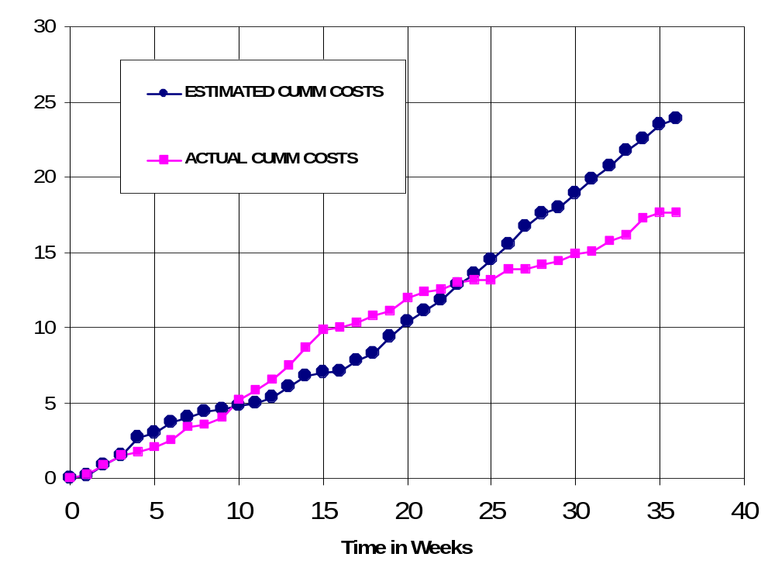
Figure 16 – Cumulative Labor Cost Graph

Economic Analysis

Table 4 illustrates in detail how much the prototype will cost. Overhead, A&G costs and profit were added to initial estimates. The total cost of the prototype is $59,270, a difference of $20,000 more than originally estimated.
Table 4 - Prototype Cost

 | Labor Rate | Initial Est. Hours | Initial Est. Cost | Current Est. Hours | Current Est. Cost
System Analyst | $45.00 | 215 | $9,686 | 113 | $5,085
Programmer | $40.00 | 268 | $10,720 | 68 | $2,720
Test Programmer | $35.00 | 31 | $1,085 | 91 | $3,185
Technical Writer | $35.00 | 67 | $2,345 | 190 | $6,650
TOTAL |  | 581 | $23,836 | 462 | $17,640
DIRECT OVERHEAD @ 100% |  |  | $23,836 |  | $17,640
SUBTOTAL |  |  | $47,673 |  | $35,280
A&G COSTS @ 40% |  |  | $19,069 |  | $14,112
SUBTOTAL |  |  | $66,742 |  | $49,392
PROFIT @ 20% |  |  | $13,348 |  | $9,878
TOTAL COST OF PROTOTYPE |  |  | $80,090 |  | $59,270

Table 5 describes unit costs if the corporation was to act as a retailer on the Internet. This calculation assumes 1,000,000 units will be sold. The first 20,000 units will recoup the cost of the prototype. The price of each copy was chosen to be $18.60.

Table 5 - Unit Costs

SOLD BY CORPORATION AS A RETAILER ON THE INTERNET
 | Initial Estimate |  |  | Current Estimate
PROTOTYPE COSTS | $80,090 |  |  | $59,270
INSTALL MACHINE AND SOFTWARE | $50,000 |  |  | $50,000
SUBTOTAL | $130,090 |  |  | $109,270
OVERHEARD @ 200% | $260,180 |  |  | $218,541
SUBTOTAL | $390,269 |  |  | $327,811
DOCUMENTATION | $0 |  |  | $0
PACKAGING SUBTOTAL | $0 |  |  | $0
SUBTOTAL | $390,269 |  |  | $327,811
A&G @ 40% | $156,108 |  |  | $131,124
SUBTOTAL | $546,377 |  |  | $458,936
PROFIT @ 20% | $109,275 |  |  | $91,787
SUBTOTAL | $655,653 |  |  | $550,723
 |  | Initial Estimate |  | Current Estimate
 | # of copies | Price/Copy | Total Profit | Price/Copy | Total Profit
Total to Sell | 1,000,000
Recoup Prototype Costs | 100,000 | $6.56 | $109,275 | $5.51 | $91,787
Excess Profit from Recoup | 100,000 | $12.04 | $1,204,347 | $13.09 | $1,309,277
Remainder to Sell | 900,000 | $18.60 | $16,740,000 | $18.60 | $16,740,000
 |  | Minus 40% for A&G | $6,696,000 | Minus 40% for A&G | $6,696,000
Subtotal |  |  | $10,044,000 |  | $10,044,000
Total Profit |  |  | $11,357,623 |  | $11,445,064

Conclusion

The previous chapters have shown the final results completed on Voice Launch. The prototype was completed in early January and there had been some extensive time to add more testing and an extra module for Continuous Recording. The project overall was a success with great results. However, if there was anything to be done differently, it would have to be allocating more time for creating the Graphical User Interface (GUI). During the design phase, the GUI was underestimated, which turned out to take a lot more time than originally planned.

References

“Dragon NaturallySpeaking 7” <http://www.scansoft.com/naturallyspeaking>
“Dynamic time warping,” < http://en.wikipedia.org/wiki/Dynamic_time_warping>
Henry, David, “David Henry Company”, < http://www.davidhenryco.com>
Hill, Pamela, “IBM ViaVoice”, <http://www-306.ibm.com/software/voice/viavoice>
Lyon, Jack, “Realize Software”, <http://www.realizesoftware.com>
“SFX Machine Glossary,”<http://www.sfxmachine.com/docs/sfx_machine_glossary.html>
Spencer, Chris, “Wizzard Software Corp.”, <http://www.wizzardsoftware.com>
Ultimate Interactive, “Ultimate Interactive Desktops Inc.” <http://www.voicestudio.us>

APPENDIX A – DEFINITIONS

Dynamic Time Warping (DTW):
Dynamic time warping is a technique applied in automatic speech recognition to cope with different speaking velocities.

GUI:
Graphical User Interface

PDL:
Programming Design Language

Template:
Holds features extracted from the WAV file and the application which will be launched for that WAV file.

WAV File:
A file format for storing digital audio data in waveform.

Zero-Crossing:
A zero-crossing occurs when a waveform changes sign by crossing the zero-amplitude axis.

Appendix B – USER MANUAL

